


Community Mental Health Recovery Courses
Grants Programme

Cheshire & Wirral Partnership NHS Foundation Trust and Cheshire West & Chester Council are commissioning a new service that aims to offer early help for adults living with poor mental health. Incorporating the principles of 5 Steps to Mental Wellbeing, the service will be recovery-focussed, offering an easily accessed resource to help assess needs, agree actions to help improve an individual’s mental health, resilience and coping strategies with the support of a coach or mentor.
To complement this commission and ensure we have structured recovery activities, courses and programmes available in community settings across Cheshire West (see map below), we are opening a new grant application process.
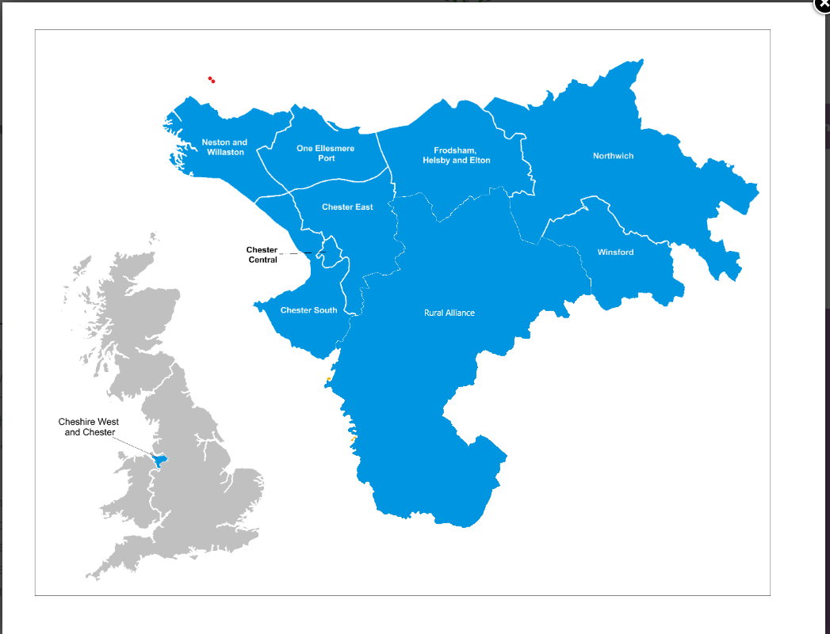
How much is available?
There is an estimated total of £105k funding available each year for the next 3-5 years (up to 2029). Any additional money identified for community mental health from our strategic partners will be used to extend this fund.
Bids are invited on an annual basis for grants to the value of £5k-£20k per annum.

Duration
Funding will be for courses and programmes delivered in the period 1st October 2024 – 30 September 2025. There is potential to extend year on year subject to funding continuing to be available and evidence of a satisfactory impact assessment.

What will we not fund?
- The purchase of capital equipment (we recognise it may be necessary to make a small investment in capital goods to develop and run the proposed courses. However, this should not exceed 10% of the funding being applied for)
- Drop-ins or ad hoc events
- Ongoing long-term support for a group or individual

What do we want to fund?
Grant applications are invited for the provision of a structured intervention that has a start and end point which aims to improve wellbeing and help people self-manage their mental health. This may be a course, a programme or a community-based activity that will form part of the individual’s personal recovery journey.

Criteria
- Your proposed course, programme or community-based activity must contribute to at least one of the following outcomes:

- feeling safe and part of their local community

- able to recognise when their mental health is struggling and know where to go and what to do to aid recovery

- knowing there is always someone available to listen and be there to check in with

- feeling more resilient and able to cope

- believing they can live their life as they wish to (including work and/or education where appropriate)

- Applicants will be expected to be currently active within Cheshire West and provide evidence of need so that we can understand what is being proposed and why. Evidence might include referral waiting lists or unmet demand from other organisations.

- Applications should also include information about how, where and when the provision will be delivered and why this approach has been taken.

- Applicants must be able to demonstrate a clear understanding of local need and the local landscape. They should be able to tell us how they will work in partnership with other mental health providers across the borough, including providers who have been commissioned to deliver recovery coaching in the borough under the recently awarded Early Access Mental Health Service contracts.

- Applicants should describe how services will be promoted to target group/s who need support. This may include outlining how applicants will work with other local partner organisations and community representatives to engage and promote the support available.

Deadline
The deadline for applications is 9 August 2024 and should be submitted to carla.preston@cheshirewest.org.uk.

How the applications will be scored
Your application will be assessed by an evaluation panel comprising people with lived experience of mental health, officers of Cheshire and Wirral Partnership (NHS), Cheshire West and Chester Council and Cheshire West Voluntary Action. The process may be opened to independent scrutiny by third parties if this is considered appropriate.

Particular consideration will be given to:
- where and how the course/programme will be run
- how the evidence of need has been identified
- how long the planned intervention will take
- how positive change will be measured for those who participate
- a demonstration of the applicant’s knowledge of and relationships with existing mental health groups and organisations within Cheshire West
- how many people could be supported through the courses proposed
.

Community Mental Health Courses and Programmes
GRANT APPLICATION FORM
Please complete all sections of the form and submit to carla.preston@cheshirewest.gov.uk by 5pm, 9th August 2024. Please direct any queries to the same email address.

Organisation Name:
Title of proposed course/programme:
Main contact for application (name/s and position in organisation):
Email address/s:
Contact phone number/s:
Organisation Address: | Full Address:  Post Code:
Please state the amount of grant funding you are requesting: | £
- Organisation Profile
Describe your organisation- please tick boxes which apply
Type of Organisation:
Registered Charity ☐
Voluntary Organisation Community Group ☐
Company Limited by Guarantee ☐
Not-for-Profit Organisation ☐
Social Enterprise ☐
Other (please describe):

How long has your organisation been in existence?

What does your organisation do? (Max 50 words)

Are you planning to deliver the project in collaboration with other organisations? Yes/ No

If yes, please provide a brief description of how you will collaborate (max 200 words)

- Describe the gap in need that your course/programme will address: (max 300 words)
Please describe how your proposed course/programme will meet the needs of the local population. If you have consulted with your intended beneficiaries or local community to establish need for your project please include this below.

- Tell us more about your course or programme, and how it will meet the needs identified in the previous section
Name of course:

Duration of course:

Number of courses you wish to provide in the next 12 months:

Method of delivery:

Location (if delivered in person):

Number of people you plan to deliver the course to in the next 12 months:

How you will measure impact (from start to end of intervention) and what tool you will use.

Which of the following outcomes will your proposed course, programme or community-based activity help individuals to achieve? Tick all that apply.

- feeling safe and part of their local community

- able to recognise when their mental health is struggling and know where to go and what to do to aid recovery

- knowing there is always someone available to listen and be there to check in with

- feeling more resilient and able to cope

- believing they can live their life as they wish to (including work and/or education where appropriate)

Course Outline: Describe how the course will address the identified need outlined in the previous section and how the funding will be used (max 250 words)

- Monitoring and Evaluation (max 300 words)
Successful applicants will be asked to report progress on the proposals set out in question 3 above. We would also like to know which outcome/s your course or programme aims to achieve and how you will measure success.
- How will the grant funding be spent?
Please detail how funding will be spent over the period of the grant.

Costs of delivering the above: | £per year
Staffing (salaries, recruitment, CRB checks etc)
Materials and resources
Venue costs (where appropriate)
Management costs
Other costs (please list)
Total grant funding requested | £

Additional information
If you are successful in your application, you will be required to provide the following information prior to the project commencing and any funding being provided. Please confirm whether the following documentation will be available prior to project commencement and how this will be evidenced. Please do not submit these documents with your application.
Documentation required | Please tick to confirm they can be provided | Please detail how this will be evidenced. If not available please provide a brief explanation.
Up to date Annual accounts | ☐
Do you have a dedicated bank account in the organisation’s name? | Yes / No
Safeguarding Policies | ☐
Evidence of Governance Structure (e.g. Board of Trustees or affiliation to a Governing Body) | ☐
Equalities, Diversity and Inclusion Policy | ☐
Appropriate levels of employee, private and public liability insurance are in place | ☐
Supplementary Questions:
Will you restrict access to your activity/project on the grounds of age, disability, gender reassignment, marriage and civil partnership, pregnancy and maternity, race, religion  and belief, sex and sexual orientation? | Yes ☐  No ☐ | If you have answered Yes - We expect all activity funded to be inclusive, if you restrict access to any groups or individuals let us know and explain why you do this:

By signing this application you agree to the best of your knowledge that all the information submitted is accurate and up to date:

Signed:
Printed:
Position:

