Council Housing Management Board Thursday 26th September 2024
Meeting Summary

Attendees:
(CW) Councillor Christine Warner – Chair and Cabinet Member for Homes, Planning and Safer Communities.
(PP) Councillor Patrica Parkes – Shadow Member for Homes, Planning and Safer Communities
(KM) Councillor Keith Miller
(AB) Allan Batty – Senior Housing Policy Officer, Cheshire West and Chester Council
(JT) Jobina Thomas – Policy Assistant, Cheshire West and Chester Council
(GD) Gemma Davies – Director of Housing and Economy, Cheshire West and Chester Council
(LH) Lucy Heath – Head of Housing, Cheshire West and Chester Council
(AS) Anthony Spurway – Tenant board member
(BMC) Brian McGaw – Tenant board member
(VG) Victoria Gabriela – Tenant board member
(PD) Paul Doughty – Independent board member
(JL) Janet Lawton – ForHousing
(KC) Karen Craig – Forhousing
(RC) Ria Carey – Cheshire West and Chester Council

Apologies:
(NH) Nigel Hickmott – Tenant board member
(JW) Jo Worthington – Independent board member
(KK) Councillor Katie Kendrick

1. Welcome
The fourth Council Housing Management Board took place with Board members being welcomed by the Chair, Councillor Christine Warner, Cabinet Member for Homes, Planning and Safer Communities.
2. Cabinet Member Update
2.1 The compliance procedures of Joseph Groom Towers, Westminster.
CW began the meeting by updating the Board about the aftermath of Grenfell and the publishing of the Review Report and the key findings. CW wanted an update on the compliance and governance procedures as well as any actions required emanating from the report recommendations. CW asked that an update is provided to Cllr Lisa Denson as the ward councillor for Westminster ward.
RC suggested inviting Cllr Lisa Denson to the drop in/walkabout so she can be reassured about their compliance and safety regulations. It will also provide her with the opportunity to ask any questions she may have. JL asked that it be noted that the upgrade to the sprinkler system will be delayed due to the national shortage of supplies, however, she wished to assure the Board that the current sprinkler system is fully operational and fit for purpose.
Action: RC to arrange a drop in with Cllr Lisa Denson regarding Groom Towers.
2.2 Ways for tenants to interact with the consultation survey.
The Council Housing Management Consultation has gone live which asks all 5,300 tenants and leaseholders to provide their views on their preferred option for the future management of the Council`s housing. AB explained that there is an online survey for tenants and leaseholders to complete and there will be a number of events and drop in sessions for tenants and leaseholders to ask questions. AB mentioned that the drop-in sessions also provided an opportunity for members of the Board to engage with tenants and leaseholders and encourage them to respond to the formal consultation.
RC asked if ward members could be provided with a QR code that links directly to the survey and allows people to complete the vote quickly. AB confirmed that this had already been actioned and J&M Consulting were leading on this work and their principal aim was to encourage a good response rate.
AB reminded the Board that all Councillors with Council housing in their ward had been sent an Information Pack outlining all the information they need to know about the formal consultation. AB continued to explain that there was a total of 2,800 tenants who had already been sent an email featuring a link to the online survey. AB also stated that all 5,300 tenants and leaseholders will be provided with a hard copy of the survey from the middle of October onwards.
CW has asked AB if there was a chance to continue the print run to provide hard copies. To which AB replied that an additional 1,500 hard copies of the survey have been printed with further print-runs taking place if deemed necessary. AB confirmed that there is a meeting scheduled with LH, the Council`s Insight and Intelligence team that oversee all consultations as well as John and Mark (consultants) on the 11^{th of} November 2024 to discuss the response rate at the halfway point with further action taking place to increase response rates if required. AB confirmed that the possibility of adding a 60 second animated video if there is a lack of engagement was also available as a plan B.
CW asked if there is a way to prevent people knocking on tenants’ doors who have already voted but it was felt that as the process is completely anonymous there will always be a risk that tenants had already responded to the survey.

3. Regulatory Compliance and Performance Board Report covering:
- Overall performance in Q4
KC provided an update on quarter 4 2023/24 performance and confirmed that of the 15 KPIs, 7 were within target, 5 were within tolerance,1 is out of target and 2 were being baselined as they are tenant satisfaction measures.
The following questions were received with answers provided as follows:
Q1: What was the reason for PMF06 re-let time (calendar days) being out of target?
KC explained that this is because there was an increase in properties requiring major works which take longer to make ready to let which pushes up the average re-let time. KC confirmed that the re-let time has jumped from 8% to 27%.
KC mentioned that steps have been taken to address this such as gaining Choice-Based Lettings Board approval to fast track the letting of over 55 properties allowing all applicants on the housing register to apply for over 55 accommodation.
3.1 TSM Performance Update - Neighbourhood and Community Standard
TP10: Satisfaction that the landlord keeps communal areas clean and well maintained that is at 46.15% which is marked red (5.85% on target.)

Q2: How are you measuring this as a percentage?

The TSM full description is “Proportion of respondents with communal areas who report that they are satisfied that their landlord keeps communal areas clean and well maintained”. Before the respondents are asked this question during the interview, they are first asked “Do you live in a building with communal areas, either inside or outside that ForHousing is responsible for maintaining?”. Only the respondents who answer “Yes” are asked the TSM question. In quarter 1 there were a total of 136 respondents, and the proportion of respondents with communal areas was 39 responded, and 18 of these were satisfied. The 46.15% was calculated (18/39). AB confirmed that a piece of work will take place during the end of the calendar year that will see a review of the service charges as well as asking tenants/leaseholders to help develop a set of service standards.

3.2 Anti-Social Behaviour and Hate incidents update

Q3a: With the 9 cases that are still open this quarter, how long have they been open for?

Q3b: With 34 cases reported regarding noise, has this been analysed or is this due to the styles of property that we have because of liveable noise?

Not sure where the 9 came from, but please see the attached analysis for the Q1 ASB cases.

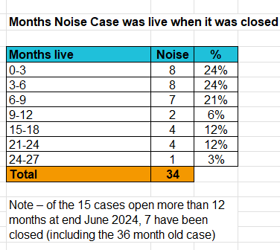
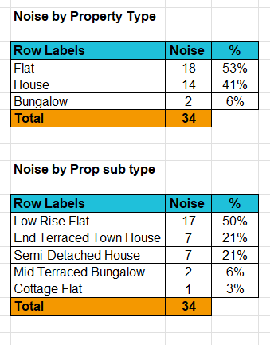
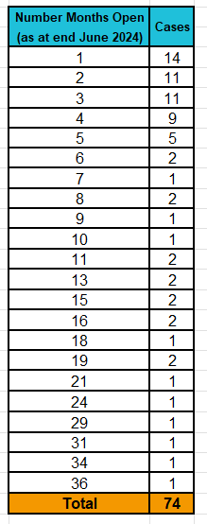
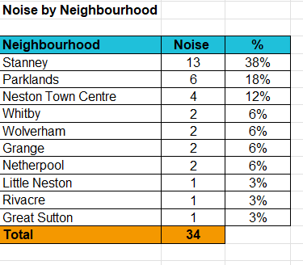

- Stock Quality, Decency, Repairs and Maintenance and Adaptations Update
Q1: Why do these properties require such extensive works?
RC explained that part of the data gathering is to investigate why properties become void with some of the termination reasons being due to the tenant passing away who often reject offers to conduct major/capital works. Of the ones that have agreed to the works, high levels of satisfaction have been achieved.
KM reminded everyone that the newly approved Council Housing Asset Management Strategy has an action which stipulates that a stratified sample of stock condition surveys is completed by yearend which will provide a more enhanced understanding of the stock condition. AB added that the entire stock is to be surveyed by March 2026, also confirming that HQN recommends as best practice that a social landlord reviews its stock every 3 years.
KC reports that the increase in tolerance at year end was due to 14 properties needing specialised windows. This revises the out turn which means that it will be recorded as out of target/tolerance. Only 2 properties have had the windows installed as of yet.
Q 2: In terms of PMF-05 percentage of pre termination visits completed where notice has been given, has the administrative error been investigated?
KC reports that there was 1 visit missed due to a housing officer’s sick leave however, this KPI still remained within tolerance.
Q3: How do we monitor decent homes?
KC stated that we clone data as the records are updated with current information. JL stated that monitoring is purely based on an age component which is why they are missed and so the stock condition survey will provide a much better picture.
Regarding the number of decent homes, 430 properties will fall out of decency during the 2024-25 period, and programs of work have been developed to ensure that all properties are decent homes compliant during the financial year, this means that this KPI will remain amber until Q4.
KC informs the group that repairs are achieving their targets, with gas safety having never been anything other than 100% (other than one missed during COVID).
- Performance in Q1
In Q1, KC confirmed that CWAC had decided to exclude the KPI of pre-termination visits after review as it was consistently being recorded at 100%. KC stated that it had also been decided by CWAC to exclude the void rent payments as it was seen as more of an input measure figure rather than having any specific tangible outcome.
KC provided an update on quarter 1 performance and confirmed that of the 13 KPIs, 9 were within target and 2 were within tolerance, with 3 being out of tolerance.
KC stated that rent collection always follows an annual trend with a spike in direct debits which collects 114.1% of rent which had the effect of decreasing rent arrears during the period.
Q1: Do you keep track of accumulative tenant engagements?
KC continued by mentioning that the KPI on the number of unique tenants engaged had already achieved 1.98% against a target of 3% so the target is likely to be easily met. GD said that it would be interesting to know how engagement has changed over the lifespan of the contract and asked if it were possible to investigate this.
Action: KC to investigate the ability of seeing how engagement has changed over the last seven years.
- Tenant satisfaction update
KC mentioned that the overall tenant satisfaction measure was out of target and tolerance. KC stated that following the last Board, she had spent time reviewing the data for this measure with themes as follows: not keeping tenant informed, reporting of damp and mould cases and time taken to complete repairs.
KC explained how the Tenant Satisfaction Measures (TSM) are surveyed and collected, KC confirmed that they are conducted by an independent body and in the form of telephone surveys with a sample taken every quarter, which is around 45 a month. These surveys are open questions that aid in providing the best insight, but analysing this information is time consuming.
KC gave an overview as follows: in total 535 surveys were carried out of which 213 gave ‘no comment’ i.e. they chose not to provide a specific comment for their satisfaction rating. KC confirmed that 178 people provided ‘satisfied’ as a response. however, it was worth noting that 53 of those respondents did not have a repair in the past 12 months.
KC stated that where details of the tenant is available staff are contacting the tenant directly to speak to them about their comment with a view to trying to resolve their complaint. KC confirmed that the overall satisfaction target for 2024/25 was 75% however, performance for quarter one was around 68%. However, due to it being a perception measure, it is harder than others to change perception. AB confirmed that ForHousing and CWAC will develop an action plan to better publicise the positive work being done for tenants and leaseholders which hopefully will feed into tenant perception.
Q1: If tenants respond with ‘no comment’, is it fair to assume that there is nothing that needs reporting/ nothing is wrong?
It was felt by all attendees that this assumption was correct as tenants who feel very strongly about the service they have received are much more inclined to comment. BMG wondered that tenants may not think that ForHousing actually read the responses from them, and this could be why tenants and leaseholders chose not to provide a comment.
AS asked if there is another way to engage with tenants to change the ‘no comments’ and increase engagement to which KC mentioned that she would investigate this. AB did however explain that there is a question within the formal consultation discussed earlier that related to the tenant perception measures so hopefully this could provide more of an insight as to what tenants and leaseholders are thinking.
- Health and Safety Update
Q1: Were the 10 accidents in Q1 related to employees or residents?
RC says that it could be both. KM asked if the percentage of near misses that ForHousing captures is an indicator of how many accidents could have occurred with RC explaining that the monthly contract reports contain a breakdown of near misses with addresses and further details.
KM asked if this could serve as an opportunity to highlight potential themes to which JL and AB agree that there is scrutiny regarding near misses but if KM wants more details, then KC/RC can create an appendix of all the narrative cases and provide this to him.
Action: KC/RC to create an appendix of all the narrative cases of near misses.
RC stated that within her Contract Compliance Team she deploys a specific member of staff to carry out inspections which all feed into the Health and Safety Forum. The Council also reports the findings to the board which highlights the level of assurance being taken.
- Estate Management and Voids and Lettings Service Update.
Q1: The average re-let time on all voids are out of target/tolerance for both Q1 and Q4, is there a reason for this?
KC explained that when targets are discussed with the Council, it is a process that involves providing CWAC officers with the evidence base along with overall sector performance. KC stated that in the case of the relet days KPI, there is a service improvement plan in place which has been drawn up by the Council with a view that ForHousing are tasked with improving their performance in this area. KC stated that ForHousing have already done some work to improve performance for example, the actual date has since improved by 2 days which is down to making improvements on the snagging time at the end of the works on void properties which occurs on 100% of properties, once at the beginning and once at the end. It is now being implemented before the works finish as a pre-emptive measure.
AB and KC confirm that across all contractors, the number of relets are not changing and it has always been stable at approximately 400 properties per annum. AB also wished to reassure the Board that the information provided to the board has been directly lifted from the contractual report that is provided to council staff.
LH stated that going forward the board report could include a confirmation that the indicator has been looked at within the contractual report and the reason for it.
VG states that she has never received an inspection to which KC and JL say that they are now conducting 5% post inspections on all repairs with all voids being inspected before they are relet. RC stated that they are planning on stripping relet times into 2 separate KPIs (general and major). This should enable performance for this KPI to come back within tolerance and if anything does spike then each void will be investigated once the information is provided for by ForHousing.
Q2: What are the aspirations for the Facilities and Maintenance figure (3.6)?
RC explained that 100% is the aspirational figure for all compliance works. She explained that the issue is getting into the properties to carry out the electrical safety checks as they do not have landlord presence to be able to get the access, so they are working alongside Legal to remedy this. It is the exact same process as the Gas servicing, so it is hard to pinpoint who makes the decision. JL reaffirmed that the power of access is with the landlord, but they have been discussing it over the past couple of months.
Q3: Regarding the housing crisis, what is the council’s view/ability to increase its housing stock at this moment in time?
CW stated that there will need to be further discussion about this outside the Board as it is outside of its remit.
JL confirmed that ForHousing/CWAC currently receive around 5 right-to-buy requests from tenants per week meaning, that in total the Council lose around 50 homes from its stock annually through the right to buy scheme.
4. Regulatory Self-Assessment update
AB stated that the self-assessment provided to him by the Housing Quality Network (HQN) had now been completed and passed to them for assessment. AB confirmed that the next steps will involve HQN staff meeting with both CWAC and ForHousing staff with a view of informing us of what needs to be done to meet the new consumer standards. AB confirmed that an introduction session has been arranged for 21st October 2024.
KC informed the group that HQN have provided them, with further information which needs collecting. The initial feedback from HQN was that there were some good examples, but they required better evidencing. This is in addition to the suggested documents being included such as a Tenant/Leaseholder Engagement Strategy which AB confirmed was currently being drafted with the help of the Tenant Participation Advisory Service (TPAS). AB explained that as part of the new Tenant/Leaseholder Engagement Strategy there will be an action plan, he continued to explain that it was hoped that the new Policy Officer will lead on this with a view that it goes to Cabinet around May 2025.
5. Any other business
5.1 Away Day discussions
CW introduced the topic of the Board Away Day but wanted to mention that she was pleased with what had been achieved by the Board to date. AB informed attendees that the day will begin with a reflection of what has gone well, what did not go to plan and what was needed for the future. AB also said that the other purpose of the day was to create a one-page summary which outlined the Council’s Housing vision and the objectives that help deliver it. AB said that Jackie from TPAS would deliver the session and would also discuss with the Board about setting up task and finish groups as opposed to a sub-committee to provide wider tenant/leaseholder scrutiny.
GD commented on the need for the board to be more visible and suggested this too could be discussed as part of the Board Away Day agenda.
5.2 Future target updates
KM discussed the announcement that all social and private rented homes must have at least an EPC C rating. AB explained that the new Council Housing Asset Management Strategy is committed to ensuring that all the Council`s housing achieves an EPC C rating by 2028 as opposed to 2030 which is the national target.
CW discussed the aim and work being done to decarbonise up to Band C before 2028 which is way ahead of the Government target. RC informed the group that they are prioritising this in the budget and placing the compliance work as a top priority.
6. Next Board Meeting
To be held on Thursday 5th December 2024.

Our council housing vision
“We aim to provide affordable homes of the right type and quality to meet the housing needs of those who are unable to meet their own needs in the housing market now and in the future. We will work in partnership to support our tenants to prosper and improve their wellbeing and ensure neighbourhoods and communities are sustainable, safe and pleasant”.

