Provider name here

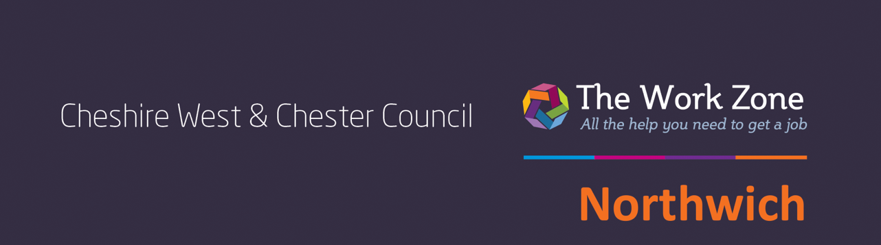

**FREE COURSE**

This course will be free for most learners. Please contact us for more eligibility details

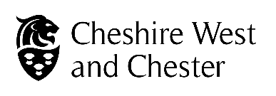

**Let’s get practical**

**A fun, friendly and**

**free 5 week course**

An opportunity to practise a range of skills including sketching, painting and collage techniques – you don’t have to be good at art! A chance to create a piece of mixed media art.

Every Thursday morning

**28 November until 5 December 2024** 9.30am – 1.30pm at

Northwich Work Zone,

Waterside House, Navigation Road, Northwich, CW8 1BE

To book your place please contact

**07833 236675** or

**northwichworkzone@**

**cheshirewestandchester.gov.uk**