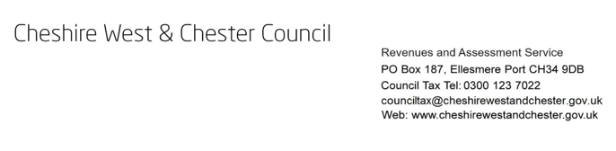

Council Tax - Discount for severe mental impairment Doctor’s certificate

*** This form MUST be completed in full and returned to: ***

Revenues and Assessment Team
Cheshire West and Chester Council
PO BOX 187
Ellesmere Port
CH34 9DB

Alternatively, you can upload a completed copy of this to our upload evidence form:
https://my.cheshirewestandchester.gov.uk/service/Upload_your_evidence

Doctor’s name and contact details | Council Tax reference number:
 | Address:

For the purposes of the Local Government Finance Act 1992, a person is severely mentally impaired if he/she has severe impairment of intelligence and social functioning (however caused) which appears to be permanent.

- In my opinion, Mr(s)/Miss …………………………………….. is severely mentally impaired and has been since: Day ______ Month _________ Year _______
- In my opinion, Mr(s)/Miss …………………………………….. is not severely mentally impaired.

Please delete A or B as applicable.
Doctor’s signature: ……………………………………….

Doctor’s full name: ……………………………………….

